TASTE OF KNOWLE WEST - ENTRY FORM  Your details  Name:  Gender: M ☐ F ☐  Address & Postcode:  Email address:  Telephone:  Date of birth: / / / | 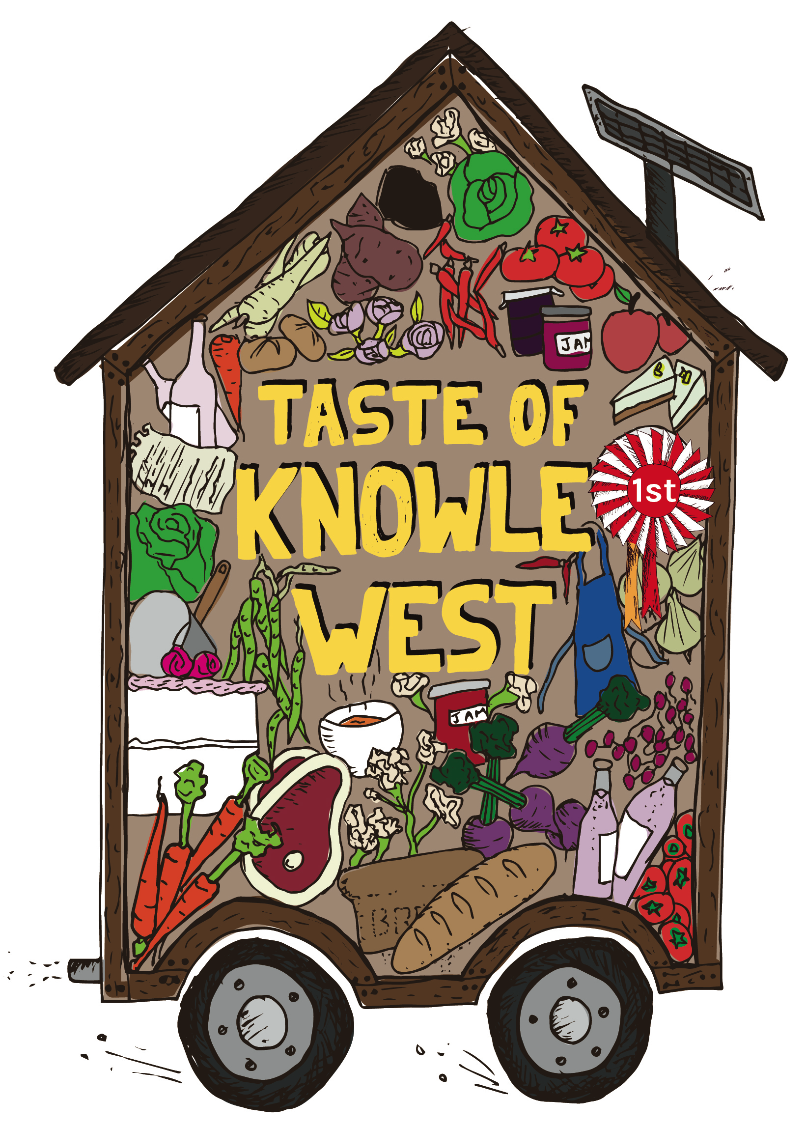

Entry details

Category entered:
A. Cake | ☐ | F. Drink or cordial | ☐
B. Bread | ☐ | G. Home-grown vegetable, fruit or edible flowers | ☐
C. Dish made with most ingredients sourced locally | ☐ | H. Wonky vegetable | ☐
D. Dish cooked by cook  under 12 | ☐ | I. Dish made from a family recipe | ☐
E. Preserve/jam/marmalade | ☐

What is the name of your entry: _____________________________________
Please attach your recipe and ingredients or write them out on the other side of this sheet. For entrants in the category ‘sourced locally’ please also tell us where you got your ingredients.

Keeping in touch

Where did you hear about the Taste of Knowle West event?

What persuaded you to attend?

Would you like to hear about future ‘Taste of Knowle West’ events? Yes / No
Please tick if you would like to subscribe to our e-bulletin to receive a free monthly e-mail about activities at KWMC ☐

Information about cooking and growing

Which ingredients were you able to get in Knowle West? __________________________
Would you like to be able to source more of your food locally? _________________________
How did you learn to cook? _____________________________________________________
Do you think cookery skills are important? _________________________________________
Do you, or anyone else in your household, grow any food? ____________________________
Do you think growing skills are important? _________________________________________

Entry notes  You can enter more than one category.  You can enter as a group, family or individual.  The Taste of Knowle West is open to people who live and work in Knowle West.  If you have any questions please contact KWMC by calling 0117 903 0444.  Bring your entry form and entry to the Shed on Wheels on Friday 15 July from 11-3.30pm. If you have preserves, veg or fruit you can bring these to the Shed on Wheels at Inns Court on Tuesday 12 July between 11-6pm. | 
Community judging will take place at 5pm on Friday 15 July on Filwood Broadway.
Entry forms will be available at the Shed on Wheels but please bring your recipe and ingredients along with you if you’re filling in a form on the day!

By signing this form you consent to your details being added to KWMC’s database. If you don’t want to receive further information from us please contact events@kwmc.org.uk or 0117 903 0444.

As part of your entry we will photograph you with your food. This will be displayed at the community judging event on Friday 15 July and in materials to document the event. It could also appear in materials produced by KWMC at a later date. If you prefer to remain completely anonymous please indicate this below and let a member of the team know.

Signed: ________________________________________________________________

