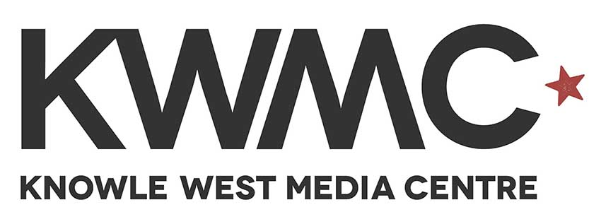

Engagement Facilitator
Application Pack

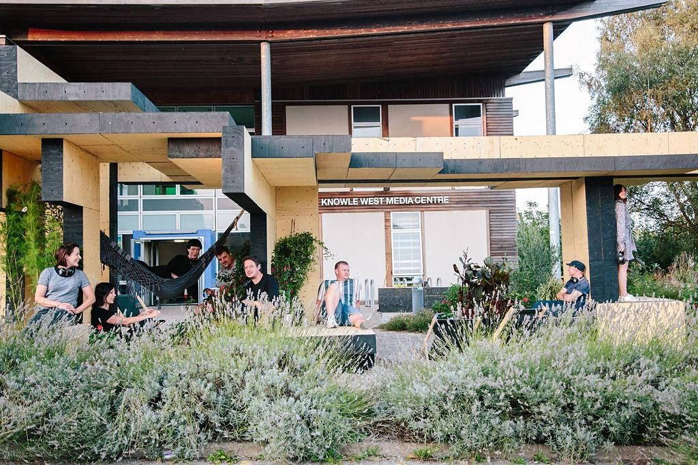

Thank you for your interest in working with KWMC

Hello. In this pack you will find more information about the job role and how to apply. Here is a bit about us. If you would like an informal chat about the role or require this application pack in an alternative format, please email michaela@kwmc.org.uk or call 0117 903 0444.

Who we are and what we do:
Knowle West Media Centre (KWMC) is an arts and digital National Portfolio Organisation (NPO) and registered charity based in Knowle West, South Bristol. Our purpose is to support people to make positive changes in their lives and communities, using technology and the arts. We have 25 years of experience in working collaboratively with people from different backgrounds to develop new and creative models for achieving positive social change. To find out more about what we do and see our values you can visit: kwmc.org.uk/about/

Job Details
Job Title: Engagement Coordinator
Salary: £24,447pa (actual £14,866 pro-rated for 22.5hours)
Hours: 22.5 hours per week. Fixed term contract until 31^{s}March 2023
Flexible working with occasional evening and weekend work as
required by the programme.
Benefits: Simpyhealth, 25 days annual leave (excluding pro-rated bank
holidays, Christmas closure and Birthday day off)
Location: Knowle West Media Centre and KWMC The Factory
Access: There is wheelchair access throughout.

Job Purpose
Working with the team to support the recruitment, delivery and administration of the South Bristol Enterprise Support Programme (MADE). Ensuring that community engagement and opportunity are at the heart of the programme’s development and formation of new and existing enterprises contributes to economic development within South Bristol.
To work together with the team to ensure a vibrant and innovative space that is safe, accessible, collaborative and inclusive.

Accountability
Accountable to The Factory Director and KWMC Trustees

Key Responsibilities
- To build relationships with groups, individuals and businesses from the local area to signpost and recruit to The Factory MADE enterprise programme and other opportunities within the KWMC programme.
- To support the outreach and recruitment of creative and digital businesses and individuals to the programme/s.
- To support the admin and delivery of inspiring and engaging sessions and workshops for the MADE programme.
- To support the marketing and communications content creation and workflow
- To support participants’ journey through the programme of activities at The Factory, including signposting to membership and progression to other opportunities. Work with the team to create an inclusive and collaborative environment.
- To work with the Creative Enterprise Manager (MADE) and team to develop an engaging, inclusive and accessible programme.
- To facilitate workshops/events as appropriate to the programme
- To support with activities and programme of work as needed within reasonable expectations.

General

- Contribute to team meetings
- Support relevant monitoring, evaluation and reports as required by MADE funders and stakeholders or internally by KWMC.
- To adhere to KWMC’s employment policies and procedures with particular. reference to Health and Safety, Data Protection, Safeguarding and Equality, Diversity and Inclusion.
- Participate in annual reviews, regular 1/2:1 check ins
- Attend any planned team training
- Advocate for KWMCs work

Key Result Areas
- To increase outreach and recruitment of creative and digital businesses/individuals to the programme/s.
- Undertake admin tasks as required for the MADE programme.
- Support with planning and delivery of high-quality training and workshops for MADE in South Bristol.
- With support of the team create and gather participants stories/journeys from different perspectives to inspire, support evaluation and communicate benefits and uniqueness of the MADE programme.
- Support the development and network of current and past MADE participants i.e., by, signposting to membership and other opportunities within KWMC programmes or external pathways.

- Communications and Working Relationships

This role requires the post holder to work with a wide range of stakeholders, from external commercial organisations, and colleagues delivering other services within KWMC, and local communities. An integral part of the job role is to ensure that good communication is maintained throughout the work delivered.

- A Commitment to KWMC’s Values

KWMC’s core values are:
- Integrity: treating others with honesty, consistency and respect, and being prepared to be held accountable for your actions
- Imagination: not being afraid to do or think differently, and being willing to explore new perspectives and creative ways of doing things
- Collaboration: working with others to achieve a shared goal, valuing the contribution and expertise that each individual brings
- Equity: recognising that in order for everyone to have an equal opportunity to succeed, some people may need additional support – then doing what you can to make this happen
- Resilience: staying faithful to your mission and values but having the flexibility to adapt to change
KWMC has developed a series of behaviours to accompany these values, which employees are expected to meet/strive towards.

- Commitment to Health & Safety, Confidentiality, Data Protection & Equal Opportunities Health and Safety/Security

It is the duty of every employee to work in such a way so that accidents to themselves and to others are avoided and to co-operate in maintaining their place of work in a tidy and safe condition, thereby minimising risk.

Confidentiality
In the course of every employee’s duties, they may have access to confidential material about members of staff, volunteers or KWMC business. On no account must information relating to identifiable people or organisations be divulged to anyone other than authorised persons. If in any doubt whatsoever as to the authority of a person or body asking for information of this nature, the employee must seek advice from their manager. Failure to observe these rules will be regarded by your employers as serious or gross misconduct, which could result in disciplinary action being taken against you.

Data Protection

Staff are required to comply with current Data Protection legislation whilst exercising their duties at KWMC, in order to protect individuals’ personal data and privacy, and ensure personal data is processed in accordance with the law. This legislation comprises the General Data Protection Regulation (GDPR) which came into force on 25 May 2018 and the new Data Protection Act (DPA) 2018.

Equal Opportunities - Our commitment

KWMC welcomes and celebrates diversity and differences between people and the strengths these bring to our communities and workforce. KWMC aims to provide excellent and efficient opportunities and services enabling everyone to fulfil their potential. To do this we must give everyone equal access to services and job opportunities.
Treating everyone the same does not necessarily give people equality of opportunity. Sometimes we need to treat people in a different way to give them the same access to a service or job.
We recognise that everyone is different and we will treat people as individuals.

October 2022

Person Specification

Essential Skills
- Friendly, patient and approachable manner with staff, members and participants
- Strong communication and mediation skills with a wide range of stakeholders
- Ability to work and engage with wide range of stakeholders and partners
- Creative outlook with good problem-solving skills
- Pro-active and self-motivated when working alone or in a team
- A commitment to developing people through engagement with arts and technology
- Active commitment to inclusion and anti-racism
- Experience of engaging people and supporting ideas development

Personal attributes and other requirements
- Prepared to undertake continued professional development.
- Flexible and prepared to work some evenings and occasional weekends
- Adaptable and flexible with needs of the programme

Desirable Skills & Attributes
- Experience of working with and facilitating workshops to a wide range of people
- Experience of planning and delivering high-quality workshops and taster sessions within communities.
- Understanding of community development and issues arising in communities regarding access to the creative tech industries
- An understanding of digital manufacturing, maker spaces and fab labs.
- Active commitment to addressing climate and ecological emergency
- Experience or knowledge of the challenges faced by small enterprises and self-employed creatives
- Experience of supporting people to access support and progression routes appropriate to their individual needs
- Experience or understanding of marketing both online and offline

General Requirements
- Professional attitude in the work place; including excellent timekeeping, ability to meet deadlines and excellent communication.
- Commitment to developing greater diversity and accessibility in the creative manufacturing and digital sector.
- Excellent interpersonal skills able to work with a broad range of stakeholders.
- Good IT literacy and file management.
- Prepared to undertake continued professional development.
- Prepared to work occasional weekends / evenings as the projects requires.
- Requirement to undertake DBS check.

Timeline
Interviews to begin : Monday 7th November 2022
We are looking for someone to start as soon as possible.

Credits
Knowle West Media Centre is supported by Bristol City Council and public funding through Arts Council England. MADE in South Bristol is delivered by KWMC The Factory as part of South Bristol Enterprise Support (SBES), which is funded by the European Regional Development Fund and West of England Combined Authority Investment Fund. SBES is delivered in partnership by Bristol City Council, YTKO, School for Social Entrepreneurs, The Prince’s Trust and KWMC The Factory.

Knowle West Media Centre is supported by Bristol City Council and supported using public funding through Arts Council England.
