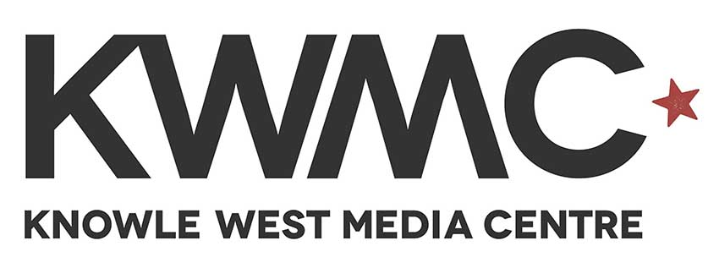

Head of Young People’s Programme
Application Pack

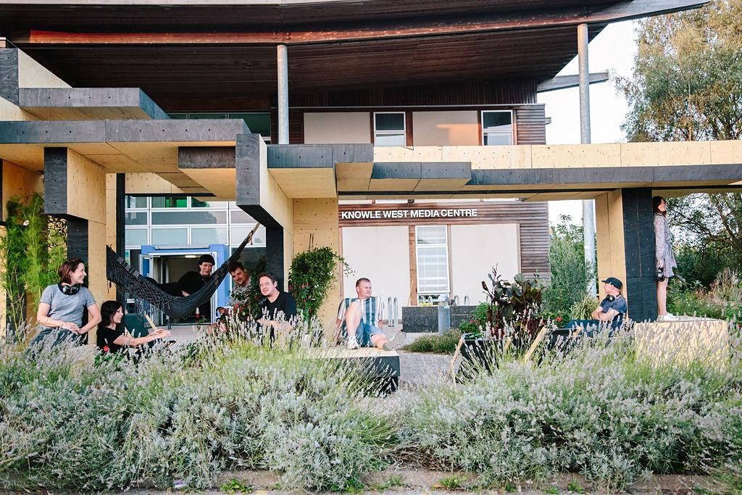

Thank you for your interest in working with KWMC

Hello. In this pack you will find more information about the job role and how to apply. Here is a bit about us. If you would like an informal chat about the role or require this application pack in an alternative format, please email michaela@kwmc.org.uk or call 0117 903 0444.

Who we are and what we do:
Knowle West Media Centre (KWMC) is an arts and digital National Portfolio Organisation (NPO) and registered charity based in Knowle West, South Bristol. Our purpose is to support people to make positive changes in their lives and communities, using technology and the arts. We have 25 years of experience in working collaboratively with people from different backgrounds to develop new and creative models for achieving positive social change. To find out more about what we do and see our values you can visit: kwmc.org.uk/about/

Job Details
Job title: Head of Young People’s Programme
Salary: £29,879 - £32,323 per annum
Hours: 37 hours per week (the postholder will be required to work until 7pm on Tuesdays to facilitate an after school programme)
Benefits: 25 days annual leave and bank holidays
Christmas closure
Birthday day off
Flexible working
Simplyhealth Wellbeing Package
Cycle to Work Scheme
Contract: Permanent
Location: Knowle West Media Centre and KWMC The Factory,
Line manager: Caryn Davies – Development Manager

Job Purpose
To lead Knowle West Media Centre’s (KWMC) young peoples’ team to ensure KWMC aims and objectives are met by overseeing the development and delivery of a high-quality programme for young people and emerging creatives and to provide day to day management of staff members.
To enable the development of the programme through building partnerships with a wide network of organisations, locally, nationally and internationally. To establish and nurture funder relationships and deliver a strategy that supports long term sustainability of this work.
To work closely with the financial team to ensure good financial management and generate income.
To work collaboratively with the leadership team to codesign the wider KWMC programme, and organizational strategy. To ensure cross team collaboration, including a shared understanding of the importance of embedded research.
To ensure training and support for team to grow.

Key Responsibilities

- To manage staff through regular meetings, including 1-1 supervision sessions and annual reviews.
- To manage stakeholder, and funder relationships and work with the finance team to ensure robust financial planning.
- To work with the management team to ensure that the organisation supports young people undertaking internships, work experience and student placements effectively.
- To work with the CEO to contribute to the KWMC business plan.
- To work closely with the Comms team to ensure young peoples’ projects and stories are being told.
- To ensure that excellent safeguarding processes are upheld within the team and across the organisation.
- To work with KWMC staff to research and develop a pool of freelance associates and volunteers as appropriate to deliver the programme.
- To ensure there is an ongoing recruitment initiative engaging young people with the KWMC programme, ensuring that hard to reach young people are included.
- To lead the development of the young people’s programme and ensure its integration within the work of KWMC, the local community and the city.
- To work closely with the wider team and sector partners to develop and expand creative networks, to develop products and services with schools, local organisations and national networks that generate income
- To be up to date with research and strategies regarding innovative approaches to education, skills, training and employment in the cultural sector.
- To support the team to maintain the KWMC database, analyse data, manage and deliver all monitoring, evaluation and reports as required by funders and stakeholders or internally by KWMC.
- To monitor activities and events to ensure high standard of delivery and compliance with current legislation in relation to working with young people.
- To work closely with the comms team to ensure that the young people’s programme content on the KWMC website.
- To disseminate good practice in relation to working with young people throughout the organisation.
- To apply for funding and seek commissions (working with the wider team) to ensure sustainability of the young people’s programme.

General
- Contribute to team meetings
- Support relevant monitoring, evaluation and reports as required by MADE funders and stakeholders or internally by KWMC.
- To adhere to KWMC’s employment policies and procedures with particular reference to Health and Safety, Data Protection, Safeguarding and Equality, Diversity and Inclusion.
- Participate in annual reviews, regular 1:2:1 check ins
- Attend and engage in any planned team training
- Advocate for KWMCs work

Key Result Areas
- The delivery of a youth programme that reflects the vision, aims and objectives of the organisation.
- An effective staff team with appropriate ongoing training programme in place.
- The successful integration of young people’s projects within the overall KWMC programme.
- Sustained involvement of young people within the youth programme with clear progression and talent development.
- Management and development of the Maker City programme, Sound Wave, Youth Council and Creative Hub as well as other young peoples’ programme projects.
- More young people benefitting from youth programme experience and actively seeking further skills training and/or employment.
- Identification and dissemination of the positive impact on young peoples’ learning and personal development as a result of participation in youth programme activities.
- An established and active youth steering group contributing to the ongoing young peoples’ programme.
- New networks and new delivery partners established and maintained at a national and international level.

Person Specification
Essential
Experience
Minimum of 3 years Project Management with demonstrable leadership skills
· Experience of managing a team of full time, part time, freelance and volunteer workers.
· Proven experience of using arts, tech, media and digital making to engage young people and demonstrable ability to keep up to keep up to date with technology.
· Experience of networking and building strategic partnerships at the highest level with a diverse range of stakeholders and partners
· A track record of overseeing the planning, managing and evaluation of arts and arts and technology projects for young people
· Experience of managing and delivering creative sessions with young people from a diverse range of backgrounds in a variety of settings
· Proven experience of using arts, tech, media and digital making to engage young people and demonstrable ability to keep up to keep up to date with technology.
· Proven experience of delivering programmes of work to a high standard.
· Experience of working within mainstream education and managing programmes of work within schools.

Skills & Abilities
· Highly effective communicator and able to write clearly to meet a range of requirements e.g. fundraising, reports, advocacy, training.
· Track record of successful fundraising (ideally for young people/arts programmes)
· Excellent interpersonal skills including the ability to negotiate, advocate and gain confidence and respect of external contacts
· High level of skills and experience in project management, planning and organising multiple tasks.
· Able to motivate and interact with people at all levels, and from a wide range of cultural, voluntary and statutory organisations, and with local people.

Knowledge
· Proven knowledge of access and inclusion issues in relation to work with young people
· Knowledge and understanding of the value and benefits of participation in the arts for young people.
· Good knowledge of national and regional policies relevant to arts, cultural education and youth arts.
· Experience of managing Child Protection procedures.
· Knowledge of issues that particularly affect young people.

Desirable Skills & Attributes
· Experience of out of school qualifications e.g. Arts Awards.
· Have one or more transferable media skills
· A broad knowledge of contemporary arts
· A management qualification
· Experience of living or working in Knowle West

General Requirements
Professional attitude in the work place; including excellent timekeeping, ability to meet deadlines and excellent communication.
Commitment to developing greater diversity and accessibility in the arts
Excellent interpersonal skills able to work with a broad range of stakeholders.
Good IT literacy and file management.
A creative problem solver with a can-do attitude
Prepared to undertake continued professional development.
Prepared to work weekends/evenings as required by the role.
Requirement to undertake an enhanced DBS check.
November 2022

Application & Recruitment Process

How to apply
Please upload a copy of your most recent CV along with a covering letter here briefly describing (approx. 1 side of A4 paper) why you are the right person for this role. Applications can also be sent by post to: KWMC, Leinster Ave, Knowle West, Bristol, BS4 1NL.
When completing your covering letter please tell us:
- A bit about your background and personal passions and motivations
- Why you are interested in the role and how you would contribute to the organisation
- How you meet the job description and person specification. Please include relevant examples of your experiences; these can be from both inside and outside of work.
Once you have submitted your application you will be asked to complete our Inclusion Form at the same time. The information you share will not be stored with, or linked to, your submission. Completing the form helps us understand whether we are reaching people from a range of backgrounds through our promotion of this opportunity. We will not use the Inclusion Form to assess your eligibility. All applications will be assessed on merit.
If you have any access needs that require you to submit your application in another format, please get in touch so we can help you find a suitable option. All applications will be assessed according to the same criteria and submitting in a different format will not affect your chances of being selected.

We operate a scheme where we guarantee an interview for anyone who identifies as D/deaf, visually impaired, disabled and/or neurodivergent and fulfils the minimum requirements of the role, as people from these groups are currently underrepresented in our workforce. If you would like this to be a consideration, please indicate this when you apply.

Offer of employment: All offers of employment are made subject to contract, receipt of at least two suitable references, an enhanced DBS check and documentation confirming your eligibility to work in the UK. If you are invited to interview, please bring details of two referees that can be contacted. These can be from your current or past workplaces, education or volunteering.

Timeline
Application deadline: Monday 12th December 2022 at 4.00 pm
interviews will be held on a rolling basis, the deadline is: Wednesday 21st December 2022

