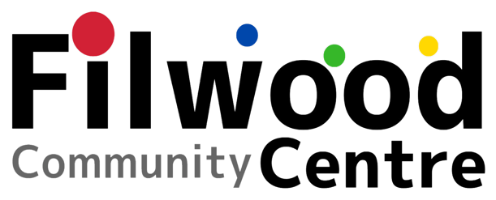
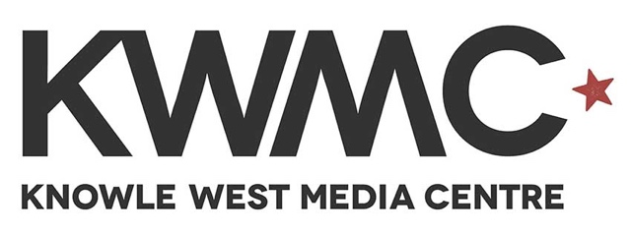

PUBLIC REALM PRODUCER
Application pack
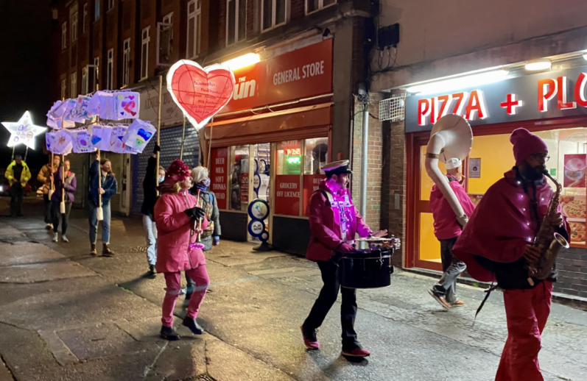

Image of the Hearts and Stars Parade from the Filwood Fantastic Project

If you require this application pack in an alternative format please email: Martha.king@kwmc.org.uk

Thank you for your interest in working with KWMC.
Hello! In this pack you will find more information about the job role and how to apply.

Who we are and what we do:

Knowle West Media Centre (KWMC) is an arts and digital National Portfolio Organisation (NPO) and registered charity based in South Bristol - Knowle West. We have been working with our local community for over 25 years to create a more thriving neighbourhood, with art tech and care.

To learn more about KWMC’s history and activity you can visit: kwmc.org.uk

High Streets Culture and Events programme:

The Priority High Streets Culture and Events Grants Scheme is part of the City Centre and High Streets Recovery and Renewal Programme funded by Bristol City Council and the West of England Combined Authorities Love our High Streets project. The City Centre and High Streets Recovery and Renewal Programme will deliver £4.725 million worth of investment, to help the city centre and high streets as we recover from the COVID 19 pandemic.

The Priority High Streets Culture and Events Grants Scheme is providing investment for Bristol based organisations to deliver cultural events and activities. These activities will bring Bristol residents together, attract and welcome visitors to the high streets and support the economic recovery of the city. A key aspect of the programme is for local communities (including businesses, residents, community groups and the arts and events sector) to play an active role in informing and codesigning the culture and events activity required for their local high street.

Filwood Community Centre (FCC) run by Community in Partnership Knowle West (CiPKW) are partners on the High Streets Culture and Event Programme. FCC led the Creative Civic Change funded Filwood Fantastic project which laid the foundation for the High Streets culture and events programme.

Images below taken from the Filwood Fantastic Project (from top left): Smoosh street performance by Paraorchestra, Filwood monthly market, FCC signage co-designed by the community and made at KWMC Factory, Open doors day, KW dance club run by Movema.

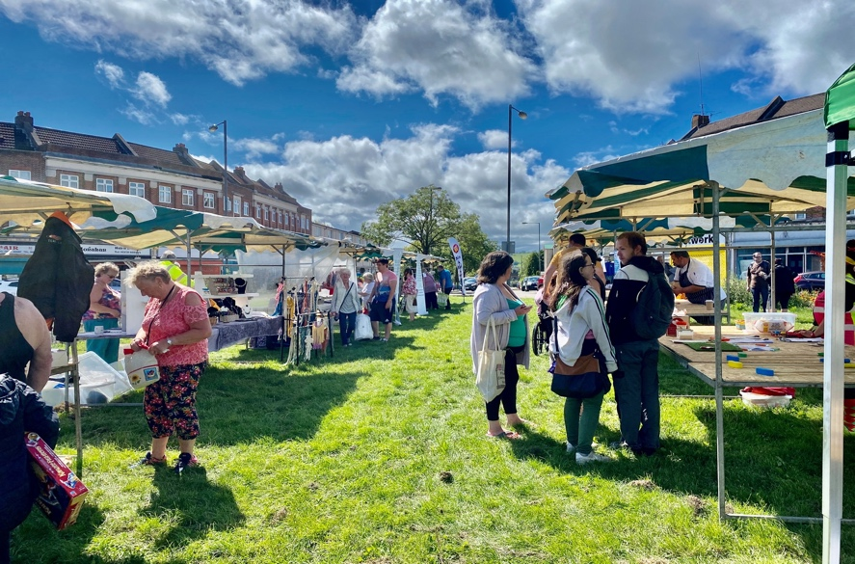
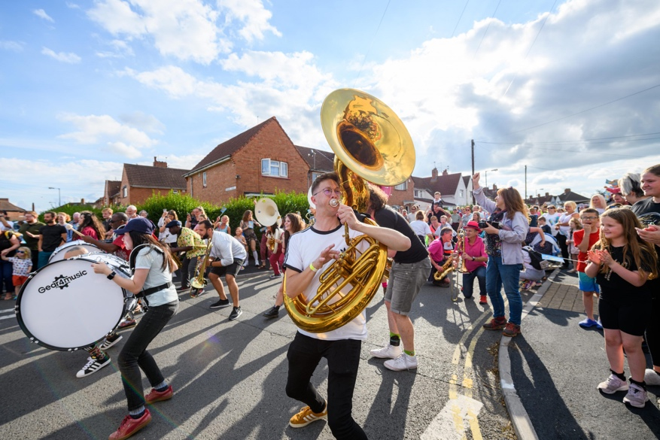

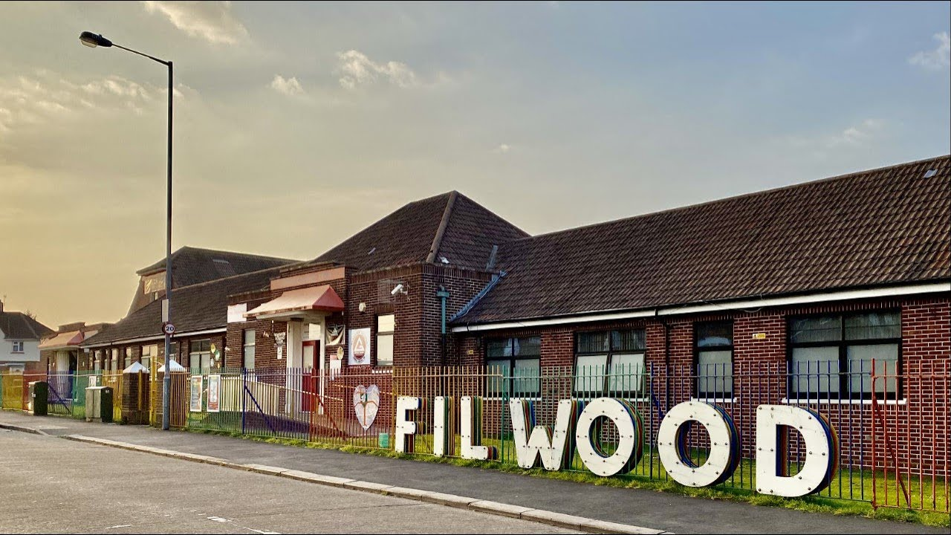

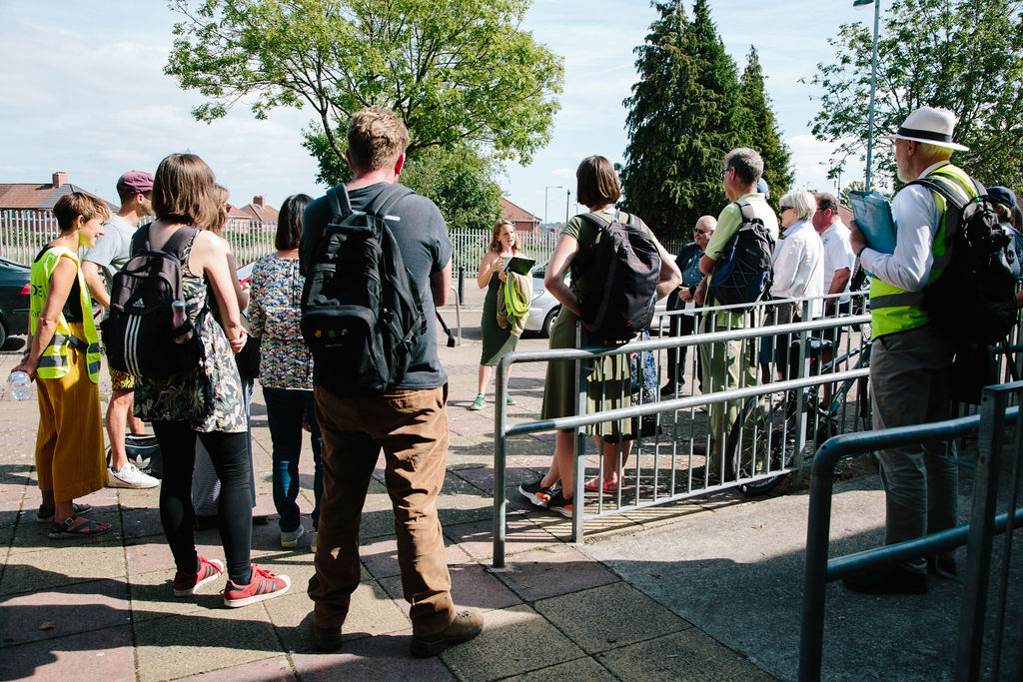
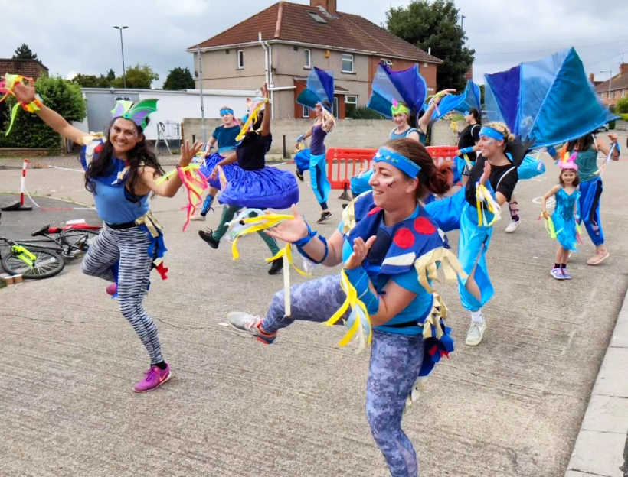

Job Description

We are looking for someone experienced in producing and project managing arts and cultural events in the public realm. This person should have a passion for working in community contexts and believe in the power of co-creation to achieve better futures for all. The ideal candidate would have experience in facilitating co-creation processes and supporting community tech projects.

We particularly welcome and encourage applications from those currently underrepresented in our workforce and in the arts community; particularly any applicant who identifies as working-class, a person of colour, transgender, non-binary or genderqueer, D/deaf, visually impaired, disabled or neurodivergent.

Job Details

Job Title: Public Realm Producer

Salary: £11,563 - £17,344 (Full time equivalent: £28,522)

Hours: Part time: 2 or 3 days a week to be negotiated (15-22.5 hours per week)

Contract: Fixed term for 12 months: February 2023 – February 2024

Location: Knowle West Media Centre, Leinster Avenue, Bristol, BS4 1NL

Line Manager: KWMC Arts Programme Manager

Job purpose

To work with KWMC Arts Programme Manager, KWMC producers and Filwood Community Centre Producers to:

- Deliver and project manage a programme of events and interventions on Filwood Broadway and support the wider KWMC public realm programming

Ensure a series of inspiring events (developed from the outlined plan in the High Streets Culture and Events bid) are delivered safely, meeting the targets and aims of the High Streets funded project and wider KWMC public realm programming.

Key responsibilities
As part of a team, you will be responsible for managing the delivery of the High Streets Culture and Events programme and supporting wider KWMC public realm programming. Including collaborating with community organisations and stakeholders, liaising with artists and creative technologists, project managing events, risk assessments, securing licenses and permissions, managing budgets and monitoring.

Person Specification
Essential knowledge, skills and experience:

Knowledge
- Public Realm events production: necessary policies, procedures
- Regeneration debates
- Best practice to deliver environmentally friendly public realm programmes
Experience of:
- Supporting co-creation processes
- Working with artists, partners and communities in a participatory way
- Project managing outdoor / public realm events
- Co-ordinating delivery teams and managing volunteers
- Managing project budgets
- Co-ordinating documentation and supporting project evaluation
Skills
- Risk assessments and necessary securing licenses and permissions for public realm events and any temporary infrastructure
- Ability to motivate, build relationships and manage people from a range of backgrounds.
- Excellent time and project management skills, with ability to focus on attention to detail while working under pressure, being self-motivated and using initiative.
- Volunteer management

Desirable
- Knowledge of the local area of Knowle West and / or South Bristol
- Community tech experience
- Co-creation facilitation experience

General Requirements
- Ability to occasionally work evenings and weekends when required

- A commitment to KWMC’s values, health & safety, confidentiality, data protection and equal opportunities policies. More information HERE

Review: This job description is subject to review and amendment in response to the changing needs of the project and will be reviewed through the ongoing appraisal process.
November 2022

Application & Recruitment Process

How to apply:
Please complete this form and upload your CV and cover letter.

In your Cover letter (2 sides max)Please include the below:
- About your background and relevant past experience
- Why you are interested in the role
- How you meet the person specification
- Any links you have to show examples of your work

Timeline
Application deadline: 11th January
Interviews: w/c 16th January
Start date: Early February 2023

Offer of employment: All offers of employment are made subject to contract, receipt of at least two suitable references and documentation confirming your eligibility to work in the UK.

Contact
If you have any questions email: Martha.king@kwmc.org.uk or call 0117 903 0444.

